Work in Optics Guide

Please complete the following steps to sign in and post jobs.

- Go to https://workinoptics.com/sign-in to access the WIO platform

- Choose “Yes, I am a member!”
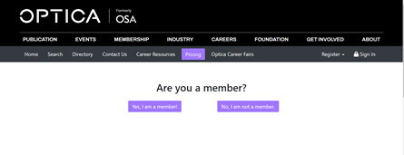

- If you have forgotten your password, click on the “Forgot your password?” link
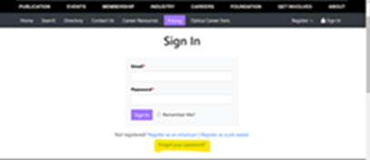
- Need to add more users to your account?

- Click Create Sub Account and fill out all required info
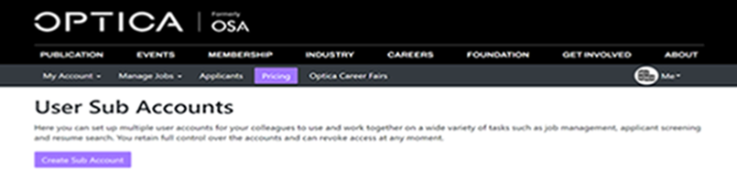
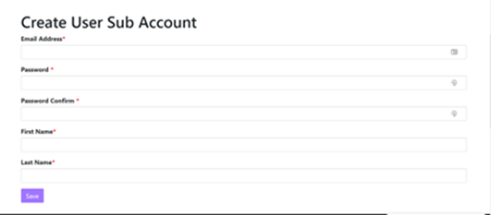

Please complete the following steps to post a job. To post a job:

- Select the “Corporate Member Pricing” tab


- Click the “Buy” button under Corporate Basic
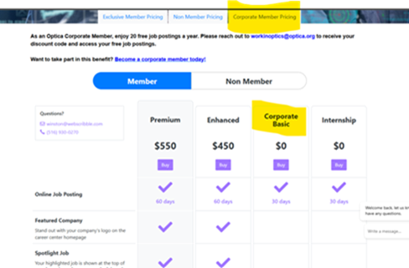
- Enter promo code : OPTICACE
- Click Apply button then click proceed to Checkout
- When the corporate member code is applied (OPTICACE) successfully, there is no cost associated with selecting the package
- Fill out all required job information on the following page and then preview and post your job!
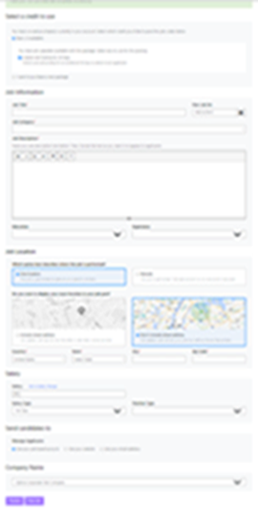

Please let us know if you need further assistance.

